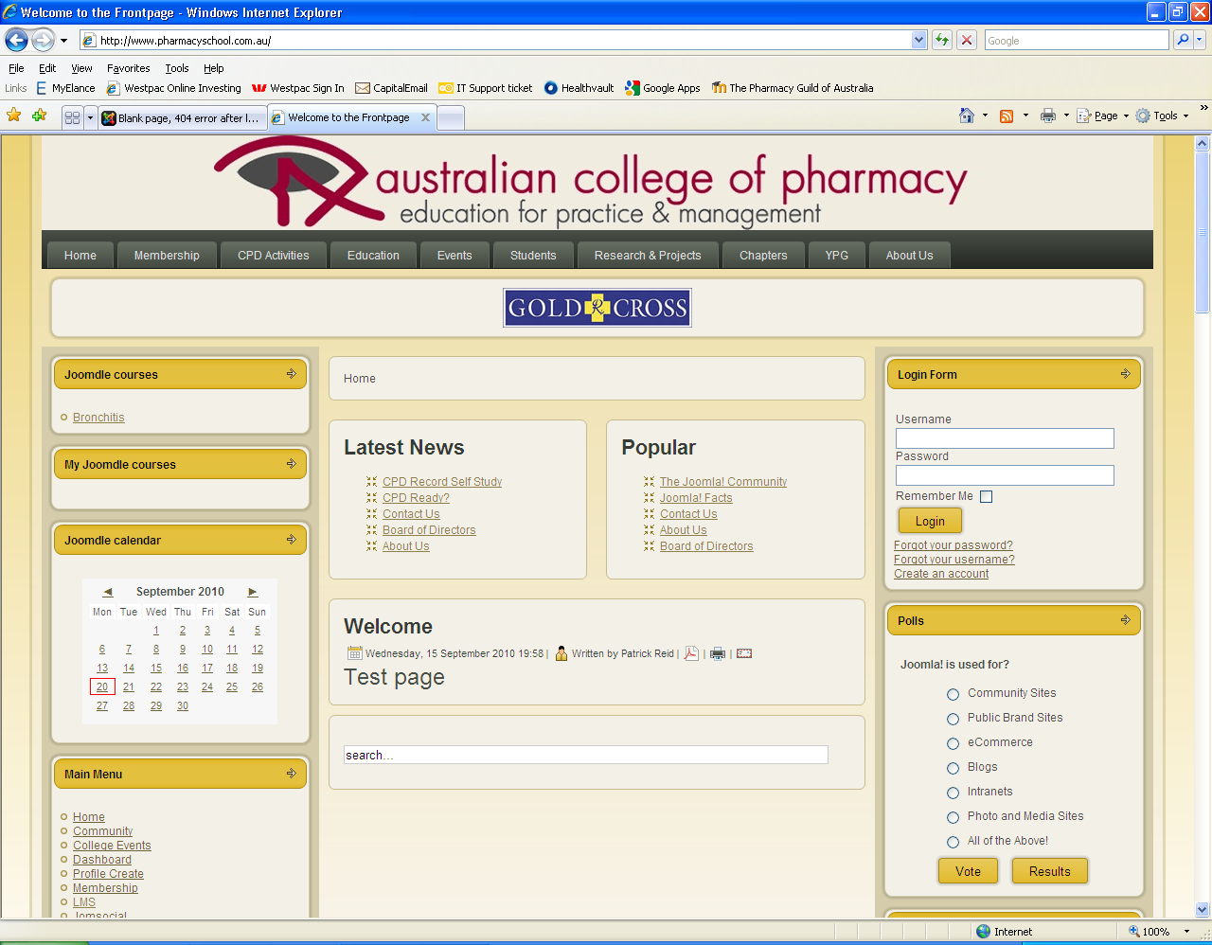
Then I log in using my admin creds
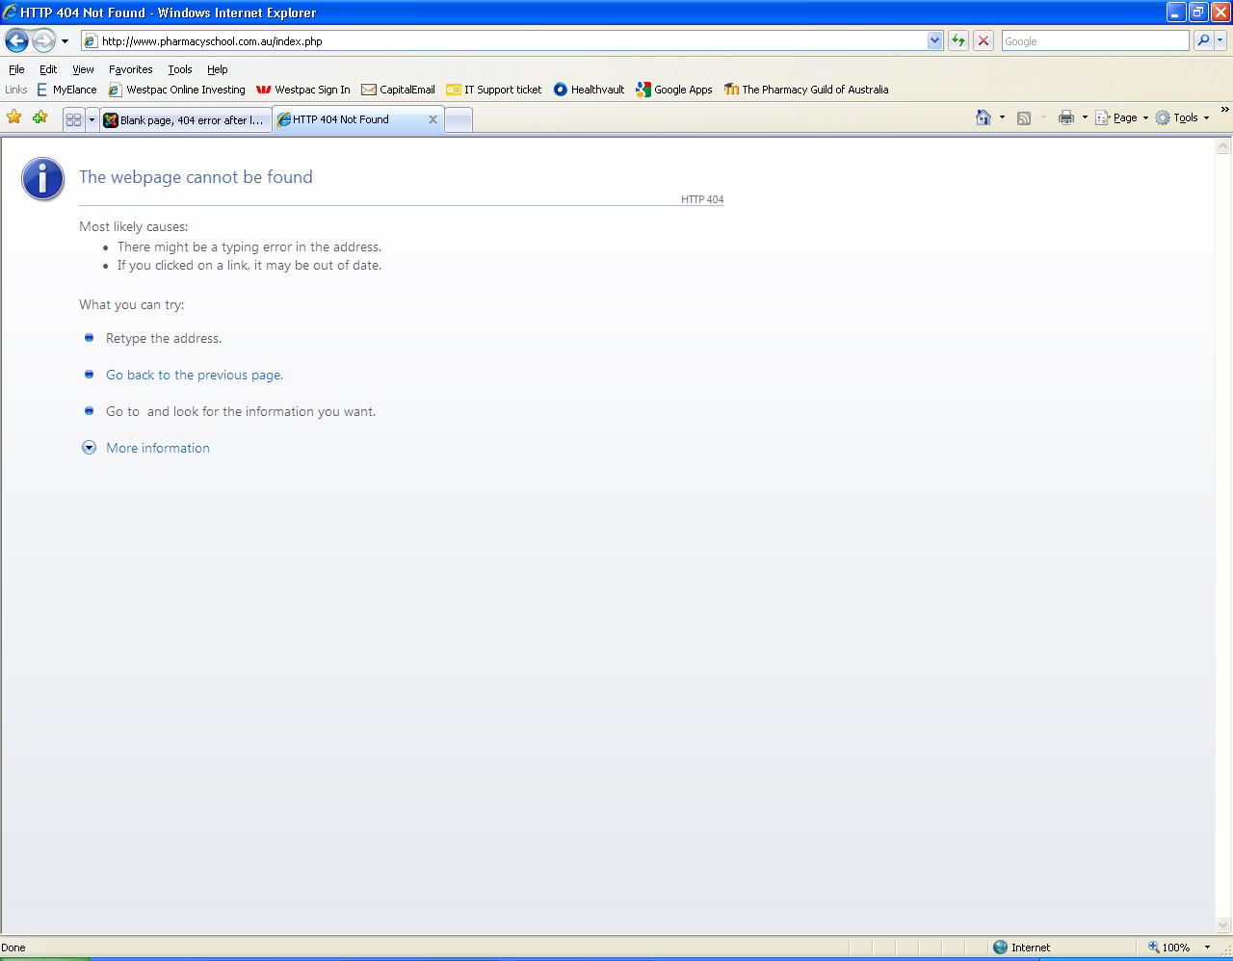
The 404 error I seem to get. Then I click refresh and....
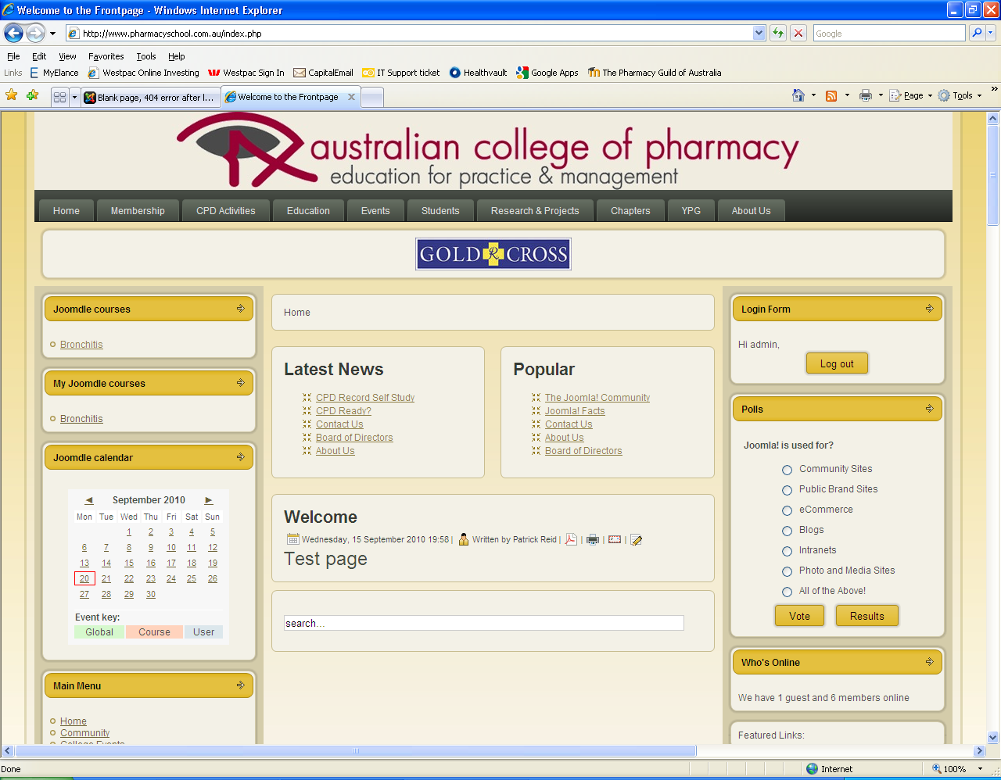
It loads with me logged in. You can see a MyJoomdle course on the left...and I click on that
I get another 404 error as its looking for this page:
http://www.pharmacyschool.com.au/lms/auth/joomdle/land.php?username=admin&token=fc00e73fc3f57e4d70cacaf7b55ba211&mtype=course&id=2&use_wrapper=0&Itemid=1
