I set a plan at the back end.
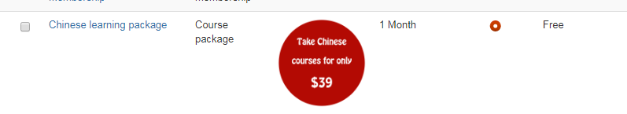
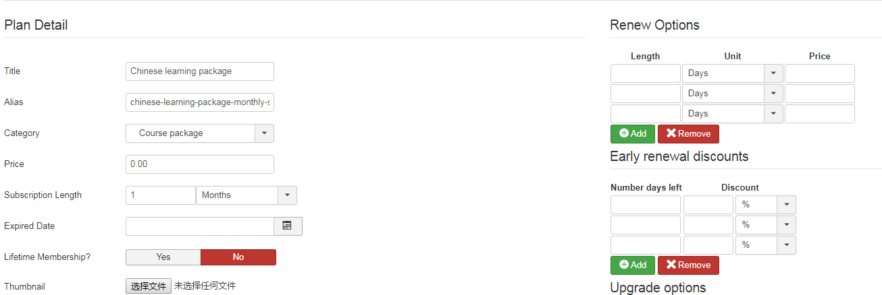
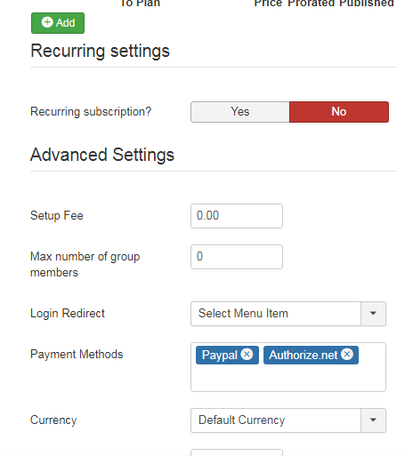
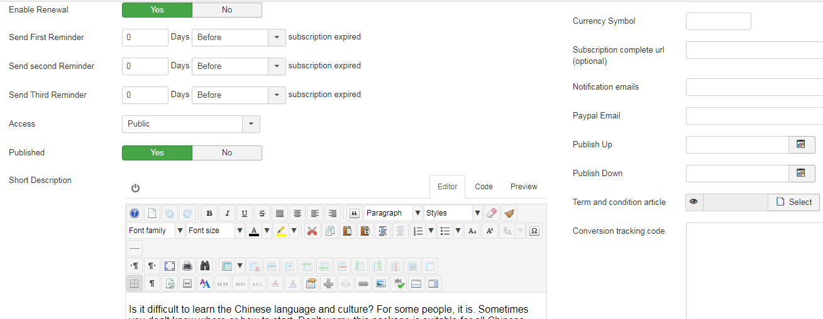
I choose a course. (I have another question: can I choose several courses at the same time? Just like choose a bundle courses, can you help us achieve that?)
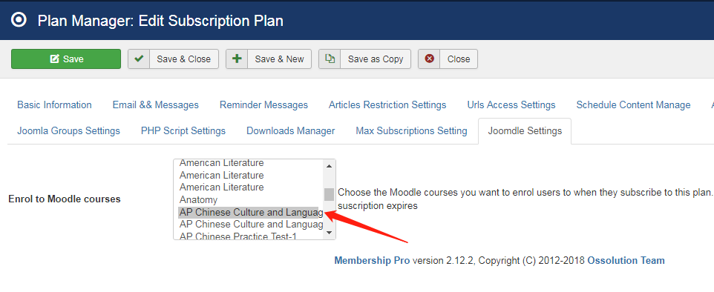

Here is how I set the menu.
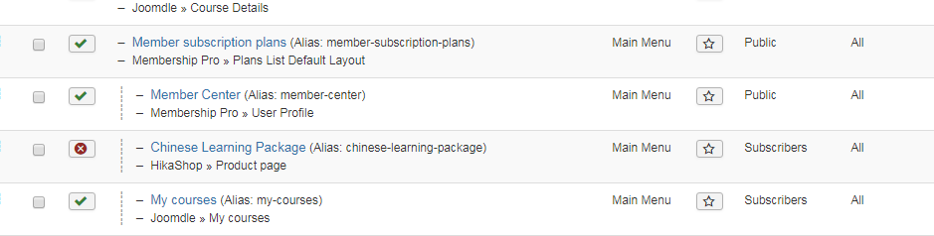
This is the menu URL
https://www.worldedu.us/stores/member-subscription-plans

Only subscribers can access to this menu “My courses”
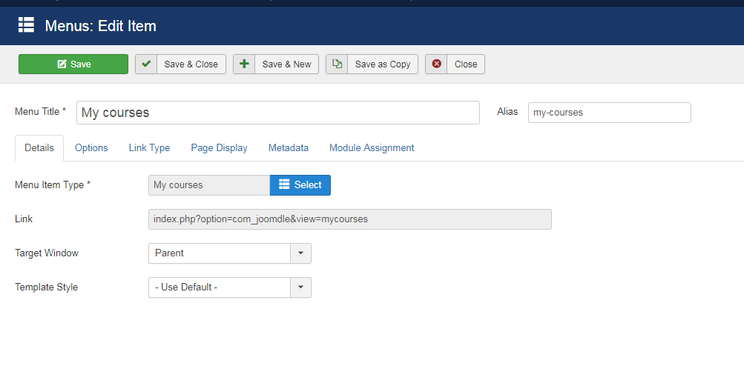
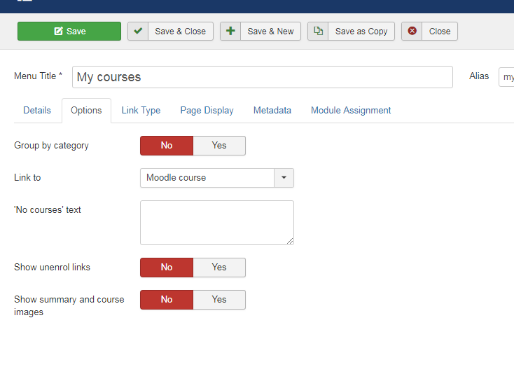
First I signed up for this plan, I registered when I sign up for it.
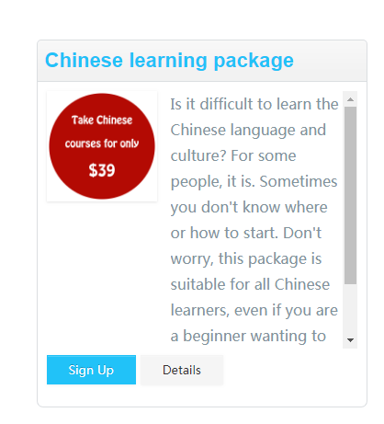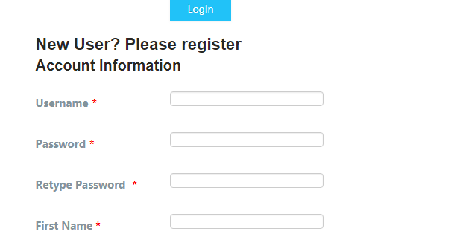

After I purchase the plan, I went to the menu “My courses” and click the course. I got the same result.
